

AMEDCO, LLC

certifies that

[INSERT NAME & CREDENTIALS HERE]

# has participated in the live activity titled

20th Annual International Pediatric Orthopaedic Symposium (IPOS®)

on December 3-7, 2024 and is awarded 18 *AMA PRA Category 1 Credits™*.

**Accreditation Statement**

In support of improving patient care, this activity has been planned and implemented by Amedco LLC and Pediatric Orthopaedic Society of North America. Amedco LLC is jointly accredited by the accreditation Council for Continuing Medical Education (ACCME), the Accreditation Council for Pharmacy Education (ACPE), and the American Nurses Credentialing Center (ANCC), to provide continuing education for the healthcare team. Professions in scope for this activity are listed below.

Amedco Joint Accreditation Provider Number: 4008163

**Physicians**: Successful completion of this program qualifies for up to 18.00 *AMA PRA Category 1 Credit(s)™.*

**Athletic Trainers**: Amedco is approved by the Board of Certification, Inc. to provide continuing education to Athletic Trainers (ATs). This program is eligible for a maximum of 18.00 Category A hours/CEUs. ATs should claim only those hours actually spent in the educational program.

**Joint Accreditation Statement**

In support of improving patient care, this activity has been planned and implemented by Amedco LLC and Pediatric Orthopaedic Society of North

America. Amedco LLC is jointly accredited by the Accreditation Council for Continuing Medical Education (ACCME), the Accreditation Council for Pharmacy Education (ACPE), and the American Nurses Credentialing Center (ANCC), to provide continuing education for the healthcare team.

Accreditation Number: 4008163.

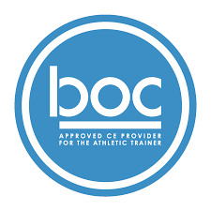WUDBHAV SANKAR, MD SECRETARY