amedco, LLC
certifies that

has participated in the live activity titled 2025 POSNA Annual Meeting held in Las Vegas, NV, USA between May 14-16, 2025 and is awarded 14 of AMA PRA Category 1 Credits™.

 | Joint Accreditation Statement    In support of improving patient care, this activity has been planned and implemented by Amedco LLC and Pediatric Orthopaedic Society of North America. Amedco LLC is jointly accredited by the Accreditation Council for Continuing Medical Education (ACCME), the Accreditation Council for Pharmacy Education (ACPE), and the American Nurses Credentialing Center (ANCC), to provide continuing education for the healthcare team. Amedco Joint Accreditation Number: 4008163. |  | 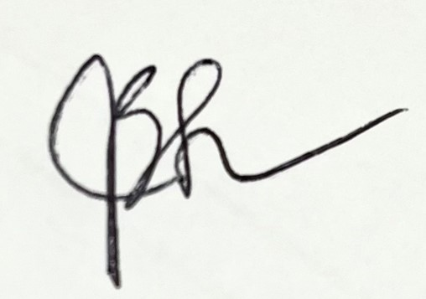
 |  |  | Julie samora, MD, PhD, MPH, FAAOS, FAOA  POSNA Program Chair

