amedco, LLC
certifies that

Click to Insert Name
has participated in the enduring activity titled 2024 Combined EPOSNA Meeting
claimed between May 12, 2024-May 12, 2025 and is awarded 5.75 AMA PRA Category 1 Credits™.

 | Joint Accreditation Statement  In support of improving patient care, this activity has been planned and implemented by Amedco LLC and Pediatric Orthopaedic Society of North America. Amedco LLC is jointly accredited by the Accreditation Council for Continuing Medical Education (ACCME), the Accreditation Council for Pharmacy Education (ACPE), and the American Nurses Credentialing Center (ANCC), to provide continuing education for the healthcare team. Amedco Joint Accreditation Number: 4008163. |  | 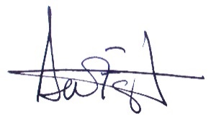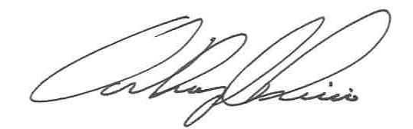
David M. FarringTOn, MD
Anthony riccio, MD
EPOSNA Program ChairS

